**Assignment 3**

**Name**: Subashini B

**Roll No**: 718019Z248

**Team ID**: PNT2022TMID12566

**Project**: News Tracker Application

**1. IBM Cloud Object Storage**

**Image.html**

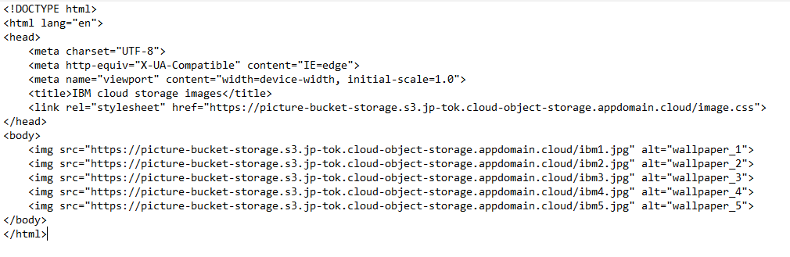

**image.css**

html{

background-color: rgb(43, 43, 43);

}

body {

display: flex;

flex-wrap: wrap;

gap: 100px;

justify-content: center;

align-items: center;

}

img {

width: 25%;

}

**Screenshot:**

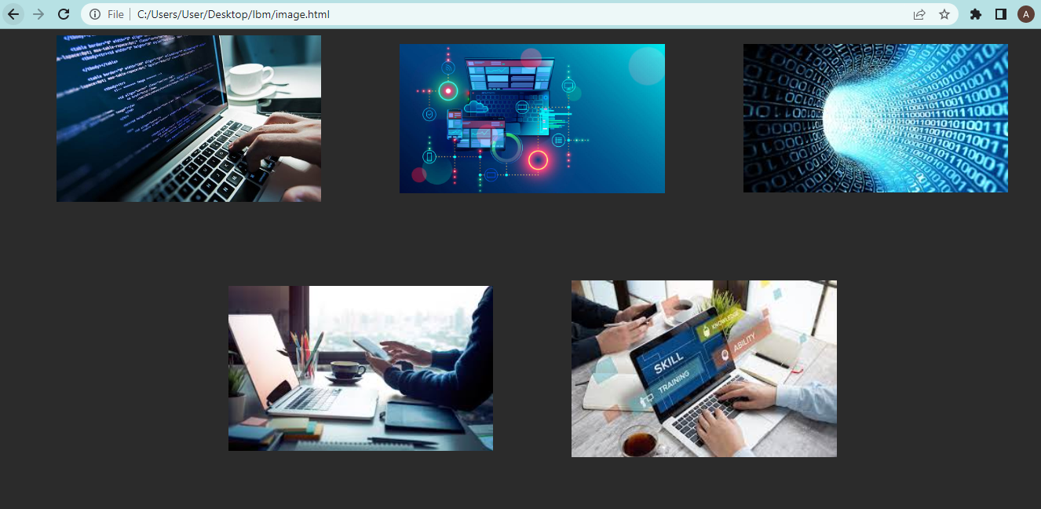

**2. IBM Watson chatbot Chatbot Link:**

<https://web-chat.global.assistant.watson.appdomain.cloud/preview.html?integrationID=b4beee6d-8e99-4d8d-accc-a83db01cf085&region=au-syd&serviceInstanceID=f1387a5f-01c2-4c2b-a52e-8e6e8d337714>

**Screenshot :**

